SCHEDULING
- Analyze the challenges of scheduling multiple processes on a single processor.
- In a uniprocessor system, contention arises because only one process can run at a time, forcing the scheduler to decide which process gets access. This limitation creates delays for waiting processes and makes fairness difficult to achieve. As the number of processes grows, the complexity of managing access increases significantly.
- Context switching is another challenge since the CPU must save and restore states whenever it shifts between processes. This overhead consumes valuable processor time that could otherwise be used for computation. Excessive switching reduces efficiency and slows overall system performance.
- Balancing throughput and fairness is difficult because maximizing efficiency often conflicts with equitable distribution of CPU time. Short processes may be favored, leaving longer or lower-priority tasks starved. The scheduler must carefully weigh these trade-offs to maintain system stability.
- Processes differ in their demands, with some being CPU-bound and others waiting on I/O operations. If scheduling does not account for these variations, the CPU may sit idle while I/O-bound tasks wait, or bottlenecks may form. Effective scheduling must adapt dynamically to these differences.
- Real-time systems add further complexity because they require strict timing guarantees that are hard to enforce on a single processor. Missing deadlines can cause instability or failure in critical applications. Designing algorithms that respect timing constraints while managing multiple processes is a major challenge.

- Differentiate between scheduling algorithms based on their impact on CPU utilization and process turnaround time.
- First-Come, First-Served (FCFS) -This algorithm executes processes in the order they arrive, which makes it simple to implement. However, long processes can block shorter ones, leading to poor CPU utilization when the processor sits idle waiting for completion. As a result, turnaround time for shorter tasks becomes unnecessarily high.
- Shortest Job First (SJF) -By prioritizing processes with the shortest burst time, SJF reduces the average turnaround time significantly. CPU utilization improves because shorter tasks finish quickly, freeing the processor for others. The drawback is that longer processes may suffer starvation, reducing fairness in scheduling.
- Round Robin (RR) -Round Robin ensures fairness by giving each process equal time slices, keeping the CPU consistently busy. This maintains good utilization, but frequent context switching introduces overhead that can reduce efficiency. Turnaround time may increase for processes with longer burst requirements due to repeated waiting.
- Priority Scheduling -This algorithm improves turnaround time for high-priority tasks by allowing them to execute sooner. CPU utilization remains strong for critical processes, but low-priority tasks may experience starvation. The imbalance between priorities can reduce overall fairness and extend turnaround time for less important jobs.
- Multilevel Queue Scheduling- By dividing processes into queues based on type or priority, this method optimizes CPU usage across categories. Turnaround time depends heavily on how queues are managed, with well-designed policies improving responsiveness. Poor queue allocation, however, can lead to inefficiency and delays for certain process groups.

- Apply a suitable scheduling algorithm to manage multiple processes on a single processor system.
- Demonstrate how CPU scheduling can optimize processor usage in a uniprocessor environment.

- CPU scheduling ensures that the single processor is never left idle when there are processes waiting. By selecting the next process efficiently, the scheduler maximizes utilization of the processor. This prevents wasted cycles and keeps the system responsive.
- Scheduling algorithms distribute processor time among processes in a way that balances workload. For example, Round Robin ensures fairness by giving each process equal time slices. This prevents monopolization of the CPU and maintains steady usage across tasks.
- By prioritizing tasks based on burst time or importance, scheduling reduces waiting time and turnaround time. Shortest Job First allows quick completion of smaller tasks, freeing the CPU for longer jobs. This optimization improves overall throughput and system efficiency.
- Schedulers adapt to the nature of processes, distinguishing between CPU-bound and I/O-bound tasks. By alternating execution, the CPU remains active while I/O operations proceed in parallel. This overlap ensures better utilization and avoids idle processor periods.
- In real-time systems, scheduling guarantees that critical tasks meet their deadlines, optimizing processor use under strict constraints. Algorithms like Priority Scheduling ensure urgent tasks are executed promptly. This maintains system stability while maximizing CPU effectiveness.

- Analyze the challenges of scheduling multiple processes on a single processor and how different algorithms address them.

- In a uniprocessor system, only one process can execute at a time, making fair distribution of CPU time a core challenge. If some processes dominate the processor, others may be delayed or starved. Round Robin scheduling addresses this by assigning equal time slices to each process, ensuring fairness and preventing monopolization.
- Preventing Starvation Processes with lower priority or longer burst times may be indefinitely delayed if the scheduler favors short or high-priority tasks. This leads to starvation, where some processes never get CPU time. Aging techniques within Priority Scheduling gradually increase the priority of waiting processes, helping to prevent starvation and ensure eventual execution.
- Efficient Processor Utilization Idle CPU time due to poor scheduling reduces system performance. For example, if I/O-bound processes are scheduled without considering their wait states, the CPU may sit idle. Multilevel Queue Scheduling and SJF (Shortest Job First) improve utilization by classifying processes and prioritizing those that keep the CPU active.
- Minimizing Overhead Frequent context switching introduces overhead, consuming CPU cycles that could be used for actual processing. Algorithms like FCFS (First-Come, First-Served) have minimal overhead due to their simplicity, though they may compromise responsiveness. Round Robin, while fair, must balance time quantum size to avoid excessive switching.
- Meeting Real-Time Deadlines Some systems require strict timing guarantees, especially in real-time applications. General-purpose schedulers may not meet these constraints. Priority Scheduling and Real-Time Scheduling algorithms (e.g., Rate Monotonic or Earliest Deadline First) are designed to prioritize time-sensitive tasks, ensuring deadlines are met without compromising system stability.
- These challenges are directly reflected in the attached goals and criteria: high processor utilization, high throughput, low response time, fairness, starvation prevention, and low overhead. Each algorithm addresses these goals differently, and selecting the right one depends on the system’s workload and performance requirements.

- Examine how scheduling decisions affect system responsiveness and resource efficiency in a uniprocessor setup.
- Apply the concept of process state transitions to explain how a blocked process can resume execution in a system with suspend states.

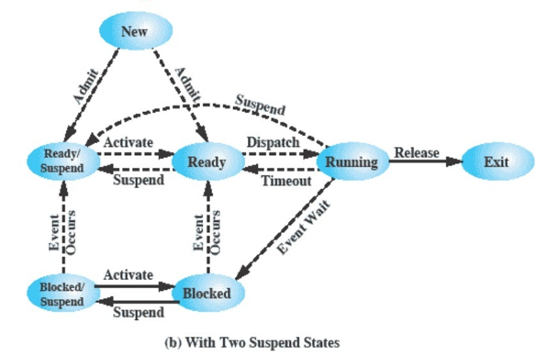
  - 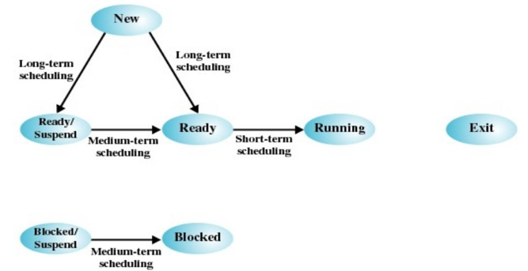
- In a system with two suspend states, a blocked process can resume execution through a structured sequence of transitions that reflect both memory management and scheduling decisions. When a process enters the Blocked state—typically due to waiting for an I/O event—it may be further moved to the Blocked/Suspend state if the system needs to free up memory or deprioritize inactive tasks. This transition is triggered by the Suspend action, which offloads the process from main memory while it remains inactive.
- Once the awaited event occurs, the process transitions from Blocked/Suspend to Ready/Suspend via the Event Occurs trigger. This indicates that the process is now eligible to run but still resides in secondary storage. To bring it back into active scheduling, the system performs an Activate operation, moving the process from Ready/Suspend to Ready, thereby restoring it to main memory and placing it in the queue for CPU allocation. Finally, the Dispatch action transitions the process from Ready to Running, allowing it to resume execution on the processor.
- This layered transition model enhances resource efficiency by allowing the system to manage memory dynamically while maintaining scheduling fairness. It ensures that blocked processes are not permanently excluded from execution and can re-enter the CPU queue once their blocking condition is resolved and memory is available.

- Using the diagram, illustrate how event-driven transitions affect the movement of processes between blocked and ready queues.

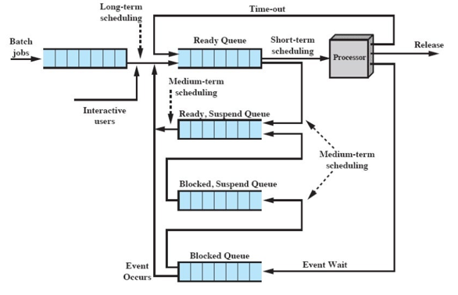
- The diagram shows how processes move through various queues and states in an operating system, particularly highlighting the role of event-driven transitions in managing blocked processes. When a process is executing in the Processor and encounters an I/O operation or waits for a resource, it transitions to the Blocked Queue via the Event Wait path. This indicates that the process cannot continue until a specific event occurs.
- If the system needs to free up memory or deprioritize inactive tasks, the process may be moved from the Blocked Queue to the Blocked, Suspend Queue through Medium-Term Scheduling. This suspended state allows the system to manage resources more efficiently while the process remains inactive.
- Once the awaited event completes—such as an I/O device responding—the process transitions from Blocked to Ready Queue, or from Blocked, Suspend to Ready, Suspend, via the Event Occurs path. These transitions signify that the process is now eligible for CPU allocation. If in a suspended state, Medium-Term Scheduling must activate the process to move it into the Ready Queue.
- From the Ready Queue, the Short-Term Scheduler selects the process and dispatches it to the Processor, allowing it to resume execution. This event-driven cycle ensures that processes are reactivated promptly once their blocking conditions are resolved, maintaining system responsiveness and efficient CPU usage.

- Analyze how short-term scheduling decisions impact both user-oriented and system-oriented performance metrics in a uniprocessor environment.

- Response time measures how quickly the system begins reacting after a user submits a request. In interactive systems, low response time improves user satisfaction and perceived system speed. Efficient short-term scheduling ensures prompt CPU allocation to reduce delays.
- Turnaround time captures the total duration from process submission to completion. It reflects overall system efficiency in handling tasks, especially in batch processing. Scheduling algorithms like SJF help minimize turnaround by prioritizing shorter jobs.
- Processor utilization indicates how actively the CPU is engaged in executing processes. High utilization means fewer idle cycles and better resource use. Short-term scheduling keeps the processor busy by quickly dispatching ready tasks.
- Fairness ensures that all processes get reasonable access to CPU time without indefinite postponement. It prevents starvation and promotes equitable treatment across tasks. Algorithms like Round Robin maintain fairness by rotating CPU access among processes.
- Throughput measures the number of processes completed per unit time, reflecting system productivity. Higher throughput means more tasks are finished efficiently. Scheduling strategies that reduce waiting and turnaround time help boost throughput.
- Waiting time is the total time a process spends in the ready queue before execution. Long waiting times indicate poor scheduling and can degrade performance. Algorithms that prioritize shorter or older tasks help reduce this delay.
- Analyze the differences between preemptive and nonpreemptive scheduling policies in terms of responsiveness and processor control.

- Preemptive scheduling enhances system responsiveness by allowing the operating system to interrupt a running process and reassign the CPU to a more urgent task. This ensures that high-priority or time-sensitive processes are serviced promptly, preventing any single process from monopolizing the processor. As a result, users experience faster reaction times, especially in interactive or real-time systems.
- Nonpreemptive scheduling, on the other hand, gives full control of the processor to a process until it voluntarily releases it—either by terminating or entering a blocked state. While this approach simplifies scheduling and reduces context-switching overhead, it can lead to poor responsiveness if long processes delay others. The system has limited control over processor allocation, which may affect fairness and delay urgent tasks.

Multiprocessor scheduling
- Apply the classification of multiprocessor systems to describe how loosely coupled and tightly coupled architectures manage memory and I/O resources.
- Loosely coupled multiprocessor systems, also known as distributed systems or clusters, consist of autonomous processors, each with its own private memory and I/O channels. These systems communicate via message passing, and resource management is decentralized. Memory is not shared, so coordination relies on network protocols and distributed scheduling.
- Tightly coupled multiprocessor systems, in contrast, feature processors that share a common main memory and operate under the integrated control of a single operating system. I/O devices may also be shared or centrally managed. This architecture allows for faster inter-processor communication and centralized scheduling, enabling efficient memory access and coordinated resource usage.

- Evaluate the suitability of fine-grained parallelism for high-performance computing tasks compared to coarse-grained models.

- With coarse and very coarse-grained parallelism, there is synchronization among processes, but at a very gross level.
- This type of situation is easily handled as a set of concurrent processes running on a multi-programmed uni-processor and can be supported on a multiprocessor with little or no change to user software.
- In general, any collection of concurrent processes that need to communicate or synchronize can benefit from the use of a multiprocessor architecture.
- In the case of very infrequent interaction among the processes, a distributed system can provide good support.
- However, if the interaction is somewhat more frequent, then the overhead of communication across the network may negate some of the potential speedup.
- In that case, the multiprocessor organization provides the most effective support.
- Apply the three design issues in multiprocessor scheduling to explain how process execution is coordinated across multiple CPUs.

Uniform Multiprocessor Architecture
- If we assume that the architecture of the multiprocessor is uniform, in the sense that no processor has a particular physical advantage with respect to access to main memory or I/O devices, then the simplest scheduling protocol is to treat processors as a pooled resource and assign processes to processors on demand.
- The question then arises as to whether the assignment should be static or dynamic.

Static Assignment
- If a process is permanently assigned (static assignment) to a processor from activation until completion, then a dedicated short-term queue is maintained for each processor.
- Allows for group or gang scheduling (details later).
- Advantage: less overhead – processor assignment occurs only once.
- Disadvantage: One processor could be idle (has an empty queue) while another processor has a backlog.
- To prevent this situation from arising, a common queue can be utilized. In this case, all processes go into one global queue and are scheduled to any available processor. Thus, over the life of a process, it may be executed on several different processors at different times.

Master/Slave Architecture
- Regardless of whether processes are dedicated to processors, some mechanism is needed to assign processes to processors.
- Two approaches have been used: master/slave and peer.
Master/Slave Architecture
- Key kernel functions always run on a particular processor. The other processors can only execute user programs.
- Master is responsible for scheduling jobs.
- Slave sends service request to the master.
Advantages
- Simple, requires little enhancement to a uniprocessor multiprogramming OS.
- Conflict resolution is simple since one processor has control of all memory and I/O resources.
Disadvantages
- Failure of the master brings down the whole system.
- Master can become a performance bottleneck.

Peer Architecture
- The OS kernel can execute on any processor.
- Each processor does self-scheduling from the pool of available processes.
Advantages
- All processors are equivalent.
- No one processor should become a bottleneck in the system.
Disadvantages
- Complicates the operating system.
- The OS must ensure that two processors do not choose the same process and that processes are not lost from the queue.
- Techniques must be employed to resolve and synchronize competing claims for resources.

Process Scheduling
- Single queue of processes or, if multiple priority is used, multiple priority queues, all feeding into a common pool of processors.
- Specific scheduling policy does not have much effect as the processor number increases.
- Conclusion: Use First-Come, First-Served (FCFS) with priority levels.

Process Dispatching
- After assignment, deciding who is selected from among the pool of waiting processes — process dispatching.
- Single processor multiprogramming strategies may be counter-productive here.
- Priorities and process history may not be sufficient.

Real-Time Networks and Networked Control Systems

- Analyze how latency, jitter, and data size influence the performance of control and monitoring systems in real-time networks.
- Latency refers to the time delay between sending and receiving data across the network.
- In control systems, high latency can cause delayed actuation or feedback, leading to instability or poor responsiveness.
- For monitoring systems, latency affects how quickly status updates or alerts are received, which is crucial for real-time decision-making.
- Jitter is the variation in packet arrival times, causing irregular data delivery.
- In control loops, jitter disrupts timing consistency, potentially causing misalignment between sensor input and actuator response.
- Systems with low jitter maintain predictable timing, which is essential for synchronized operations like robotic control or industrial automation.
- Smaller data packets (few bytes) are preferred in real-time systems to reduce transmission time and processing overhead.
- Large data sizes increase buffering, queuing, and transmission delays, which can degrade performance in time-critical applications.
- Efficient handling of small, frequent packets ensures timely updates and minimal congestion, especially in periodic monitoring and alarm signaling.
- Evaluate the advantages and limitations of time-triggered networks compared to event-triggered models in real-time system design.

Time-triggered networks

- More deterministic
  - All transmission instants are predefined
  - Fault-tolerance mechanisms are easier to design
- Less flexible in reacting to errors
  - Retransmissions often not possible because the schedule is fixed
  - A lost message is not recovered until the next period of the message stream
- Less flexible with respect to changes
  - Everything must be known at design time and very little can be changed dynamically (cp. static cyclic CPU scheduling)
Event-triggered networks:
- Lower level of determinism
  - Events can occur at any time (flexible)
  - MAC protocol may be needed
  - Harder to give hard real-time guarantees
- More complex fault-tolerance schemes
- More flexible with respect to transmission errors
  - Retransmissions can be carried out immediately

- Explain the concept of a collapsed OSI model and its relevance in fieldbus-based industrial automation networks.
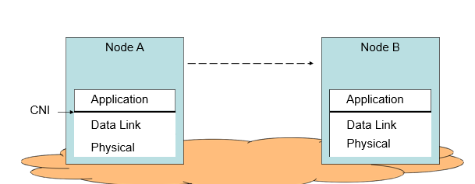
- Application Layer: Each node (e.g., Node A and Node B) initiates communication through its application layer, which directly accesses the data link layer without relying on presentation, session, or transport layers. This simplifies protocol handling and accelerates message delivery.
- Data Link Layer: Responsible for framing, addressing, and error detection, the data link layer ensures reliable transmission between nodes. It manages access to the shared medium and coordinates message exchange without the need for complex routing or transport protocols.
- Physical Layer: The actual transmission of bits occurs over the physical medium (e.g., twisted pair, fiber optic), connecting Node A and Node B through the fieldbus network.
- Efficiency: Because fieldbus systems are typically confined to a single network domain and dedicated to specific industrial tasks, the collapsed model avoids fragmentation, reassembly, and routing overhead—ensuring deterministic and time-bounded communication.

- Analyze the architecture of VxWorks and its role in supporting real-time responsiveness.

System Level Functions- These manage core OS operations like memory allocation, timers, and interrupt handling. They provide foundational services required by all tasks and subsystems. Examples include task creation, system initialization, and clock management. They ensure the RTOS maintains predictable and stable execution.

Task Service Functions-These support task behavior such as delays, sleep, and periodic execution. They allow tasks to yield CPU time or wait for specific conditions. Examples include task delay, resume, and suspend operations. They help structure multitasking and time-triggered execution.

Task Control Functions-These manage task states, priorities, and transitions between ready, running, or blocked. They enable dynamic scheduling and preemption based on system needs. Examples include setting task priority or deleting a task. They ensure efficient CPU allocation and responsiveness.

Interprocess Communication (IPCs)-IPC functions allow tasks to exchange data and synchronize execution. They include semaphores, message queues, and shared memory. These mechanisms prevent race conditions and coordinate task interaction. They are critical for real-time coordination and resource sharing.

Network and I/O Functions-These handle communication with external devices and network interfaces. They support protocols, drivers, and data transfer operations. Examples include socket management, serial port access, and Ethernet handling. They enable real-time systems to interact with sensors, actuators, and remote nodes.
- VxWorks is a Unix-like real-time operating system made and sold by Wind River Systems of Alameda, California" USA. Like most RTOSes, VxWorks includes a multitasking kernel with pre-emptive scheduling and fast interrupt response, extensive inter-process communications and synchronization facilities, and a file system Major distinguishing features of VxWorks include efficient POSlX-compliant memory management, microprocessor facilities, a shell for user interface, symbolic and source level debugging capabilities, and performance monitoring. VxWorks is generally used in embedded systems. Unlike "native" systems such as UNIX and Forth, VxWorks development is done on a "host" machine running Unix or Windows, crosscompiling target software to run on various "target" CPU architectures as well as on the "host" by means of VxSim. VxWorks has been ported to a number of platforms and now runs on practically any modern CPU that is used in the embedded market. This includes the x 86 families, MIPS, PowerPC, SH-4 and the closely related family of ARM, StrongARM and xScale CPUs
VxWorks System Functions and System Tasks
- The first task that a scheduler executes is UsrRoot from the entrv point of usrRoot0 in file
- install/Dir/target /config/alI / usr/Confi g. c.
- It spawns the VxWorks tools and the following tasks. The root terminates after all the initializations. Any root task can be initialized or terminated. The set of functions, tlog Task, logs the system message without current task context I/O.
Interrupt handling functions
- An internal hardware device auto generates an interrupt vector address, ISR- ECTADDR as per the device. Exceptions are defined in the us6r software.
ISR Design
- ISR have the highest priority and can preempt any running task.
- An ISR inhibits the execution of the tasks till return’.
- An IRS does not execute like a task and does not have regular task context. It has special interrupt context'
- While each task has its own stack" unless and otherwise not permitted -by a special architecture of a System or a processor
- An ISR should not wait for taking the semaphore or other IPC.
- ISR should just write the required data at the memory or post an IPC so that it has short codes and most of its functions, execute at tasks.
- ISR should not use flodting-point functions as these takes longer time to execute.
Signals and interrupt handling functions
- Function 'void sigHandler(int sigNum)' declares a signal servicing routine for a signal identified by sigNum and a signal servicing routine registers a signal as follows:
- Signal (sigNum, sigISR). The parameters that pass are the sigNum and signal servicing routine name, sigISR.A pointwer pSigCtx associates with the signal context. The signal xcontewxt savwes PC, SP, registers, etc. like an ISR context.
- The signal ISR calls the following functions: Call taskRestart0, to restart the task which generated the sigNum. Call exit0 to terminate the task, which generated the sigNum.
- Call longiumpO. This results in starting the. Execution from a memory location.

#include <pthread.h>
#include <semaphore.h>
#include <stdio.h>
#include <unistd.h>

sem_t sensor_done; // Semaphore to signal sensor completion

void* sensor(void* arg) {
printf("Sensor: Collecting data...\n");
sleep(1); // simulate sensing delay
printf("Sensor: Data ready.\n");
sem_post(&sensor_done); // signal controller
return NULL;
}

void* controller(void* arg) {
sem_wait(&sensor_done); // wait for sensor
printf("Controller: Processing sensor data...\n");
sleep(1); // simulate processing
printf("Controller: Control decision made.\n");
return NULL;
}

void* actuator(void* arg) {
printf("Actuator: Executing control action...\n");
sleep(1); // simulate actuation
printf("Actuator: Action completed.\n");
return NULL;
}

int main() {
pthread_t t1, t2, t3;
sem_init(&sensor_done, 0, 0);

pthread_create(&t1, NULL, sensor, NULL);
pthread_create(&t2, NULL, controller, NULL);
pthread_create(&t3, NULL, actuator, NULL);

pthread_join(t1, NULL);
pthread_join(t2, NULL);
pthread_join(t3, NULL);

sem_destroy(&sensor_done);
return 0;
}
QUESTION ONE [30]
- Define the term real time system.. [2]
- A real-time system is any information processing system which has to respond to externally generated input stimuli within a finite and specified period
- the correctness depends not only on the logical result but also the time it was delivered
  - failure to respond is as bad as the wrong response!

- State the resilient features of RTOS [4]
responsibility of RTOS

- 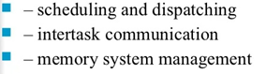
- Input and output system management
- Timing
- Error management
- Message management

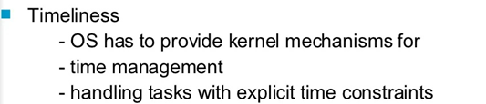
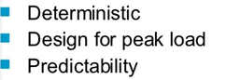
- Explain the concept of Race condition in OS [4]
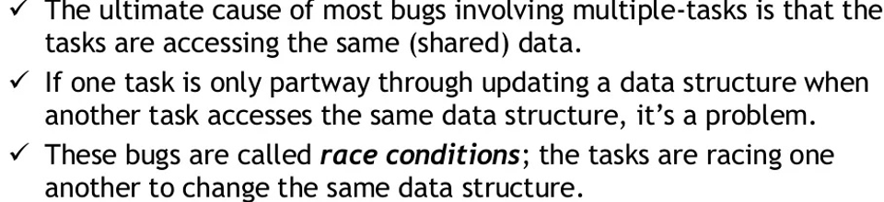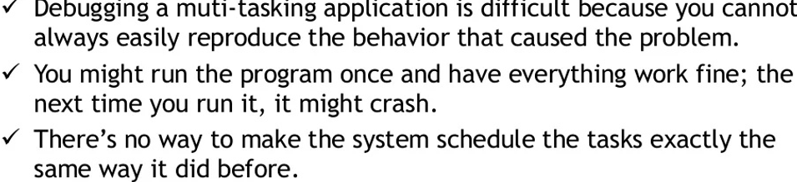
- Define the following terms: [3]
- Priority
- Static Priority
- Dynamic Priority
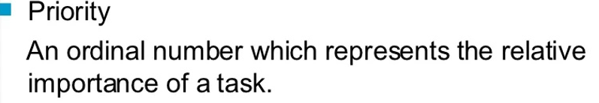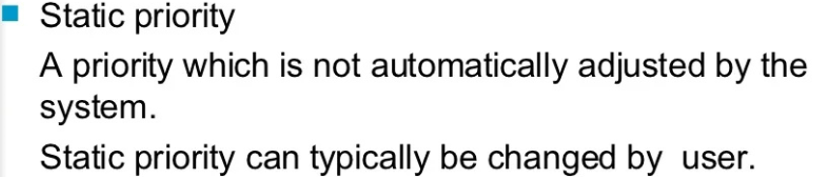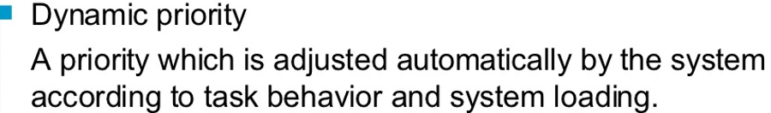
- Explain how RTOS does dynamic memory allocation in Real Time Programing
[3]
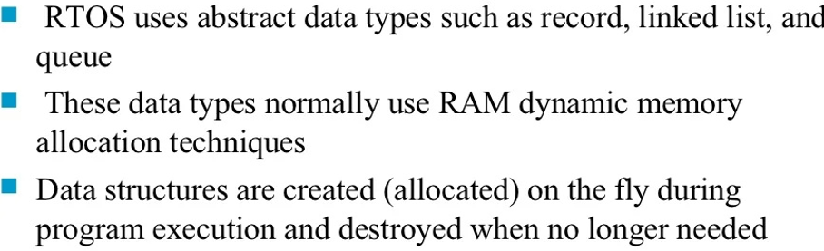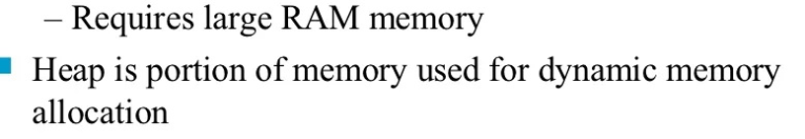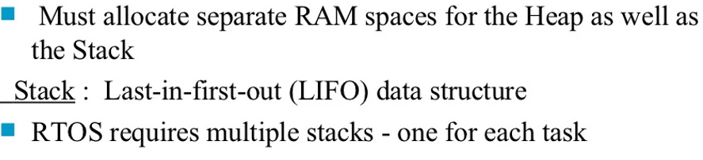
- Discuss the three devised Methods that are aavaiable in evaluating CPU scheduling algorithms. [6]

- Simulation:
  - Get the workload from a system
  - Simulate the scheduling algorithm
  - Compute the performance metrics based on simulation results
  - This is practically the best evaluation method.
- Queueing models:
  - Analytically model the queue behavior (under some assumptions).
  - A lot of math, but may not be very accurate because of unrealistic assumptions.
- Deterministic Modeling
  - Take a predetermined workload
  - Run the scheduling algorithm manually
  - Find out the value of the performance metric that you care about.
  - Not the best for practical uses, but can give a lot of insides about the scheduling algorithm.
    - Help understand the scheduling algorithm, as well as it strengths and weaknesses

- Explain how synchronization is achieved through inter- process mechanism in real time programming [3]
- Message passing may be either blocking or non-blocking
- Blocking is considered synchronous
  - Blocking send has the sender block until the message is received
  - Blocking receive has the receiver block until a message is available
- Non-blocking is considered asynchronous
  - Non-blocking send has the sender send the message and continue
  - Non-blocking receive has the receiver receive a valid message or null
- Define the following terms as used in Real Time Programming systems: [5]
- Inter process communication.
Inter-process communication (IPC) is a set of techniques for the exchange of data among multiple threads in one or more processes. Processes may be running on one or more computers connected by a network. IPC techniques are divided into methods for message passing, synchronization, shared memory, and remote procedure calls (RPC). The method of IPC used may vary based on the bandwidth and latency of communication between the threads, and the type of data being communicated.

- Semaphore

Semaphores -- software, blocking, OS assistance solution to the mutual exclusion problem basically a non-negative integer variable that saves the number of wakeup signals sent so they are not lost if the process is not sleeping another interpretation, we will see is that the semaphore value represents the number of resources available

- Synchronization-

- Message passing can be either blocking or non-blocking. Blocking is considered to be synchronous and non-blocking is considered to be asynchronous.

- Mailbox and Pipe

- Mailboxes are software-engineering components used for interposes communication, or for inter-thread communication within the same process. A mailbox is a combination of a semaphore and a message queue (or pipe).
- Message queue is same as pipe with the only difference that pipe is byte oriented while queue can be of any size.

    - Explain briefly how network protocols works in real time programming systems.

[2]
- Network protocols break larger processes into discrete, narrowly defined functions and tasks across every level of the network. In the standard model, known as the Open Systems Interconnection (OSI) model, one or more network protocols govern activities at each layer in the telecommunication exchange. Lower layers deal with data transport, while the upper layers in the OSI model deal with software and applications.
- A set of cooperating network protocols is called a protocol suite. The Transmission Control Protocol/Internet Protocol (TCP/IP) suite, which is typically used in client-server models, includes numerous protocols across layers -- such as the data, network, transport and application layers -- working together to enable internet connectivity. These include the following:
- TCP, which uses a set of rules to exchange messages with other internet points at the information packet level;
- User Datagram Protocol, or UDP, which acts as an alternative communication protocol to TCP and is used to establish low-latency and loss-tolerating connections between applications and the internet;
- IP, which uses a set of rules to send and receive messages at the level of IP addresses; and

QUESTION TWO [20]
- Explain how Real time Systems are classified. [8]

- Hard real-time systems

- An overrun in response time leads to potential loss of life and/or big financial damage
- Many of these systems are considered to be safety critical.
- Sometimes they are “only” mission critical, with the mission being very expensive.
- In general there is a cost function associated with the system.
  - Soft real-time systems
  - Deadline overruns are tolerable, but not desired.
  - There are no catastrophic consequences of missing one or more deadlines.
- There is a cost associated to overrunning, but this cost may be abstract. • Often connected to Quality-of-Service (QoS)

Firm teal-time systems
- The computation is obsolete if the job is not finished on time.
- Cost may be interpreted as loss of revenue.
- Typical example are forecast systems.
Weakly hard real-time
- Systems where m out of k deadlines have to be met.
- In most cases feedback control systems, in which the control becomes unstable with too many missed control cycles.
- Best suited if system has to deal with other failures as well (e.g. Electro Magnetic Interference EMI).
- Likely probabilistic guarantees sufficient
Non- Real Time system
- Yes, those exist!
- However, in most cases the (soft) real-time aspect may be constructed (e.g. acceptable response time to user input).
- Computer system is backed up by hardware (e.g. end position switches)
- Quite often simply oversized computers

- What are fixed priority scheduling. [4]
- Priorities may assigned by
  - Deadline: shortest deadline _ highest priority
  - Period: shortest period _ highest priority
  - “Importance”
- Scheduler picks from all ready tasks the one with the highest priority to be dispatched.
- Benefits:
  - Simple to implement
  - Not much overhead
  - Minimal latency for high priority tasks
- Drawbacks
  - Inflexible
  - – Suboptimal (from analysis point of view)

- Explain the following terms [8]
- priority inheritance
- ceiling priority protocol
- Immediate priority ceiling protocol
priority inheritance

When lower priority job blocks, it inherits priority of blocked job.
• GOOD
– No unbounded priority inversion
– Simple
– No prior knowledge required
– Works with fixed and dynamic priorities.
• BAD
– Possible Deadlock.
– Blocking of jobs not in resource contention.
– Blocking time could be better
– Indirection a pain in the neck
Basic ceiling priority protocol
Lower priority task inherits priority of blocked task.
• Task may be denied resource even when available.
• Also known as Original Priority Ceiling Protocoll (OPCP)
• GOOD
– No deadlock.
– No unbounded priority inversion.
– Blocking time reduced.
• BAD
– Task may be denied resource even when available.
– Need a priori knowledge of use of resources.
Immediate priority ceiling protocol

- Lower priority task inherits priority of potentially blocked task. Task may be denied resource even when available.
GOOD
  - Simple.
  - Shared run-time stack.
  - Reduced Context-Switching
  - No deadlock.
  - No unbounded priority inversion.
BAD
  - Task may be denied resource even when available
- Task may be affected by blocking effect without using any resources
  - Need a priori knowledge of use of resources.
  - No self suspension while holding a resource

QUESTION THREE [20]
- Explain the concept of Rate monotonic scheduling algorithm in RTOS. [6]
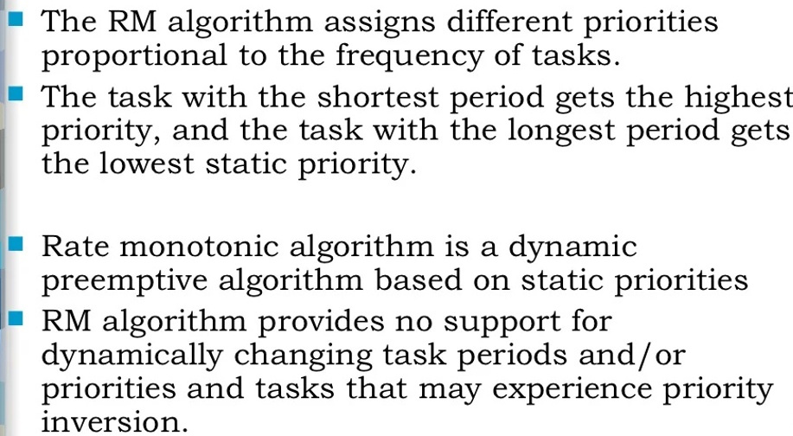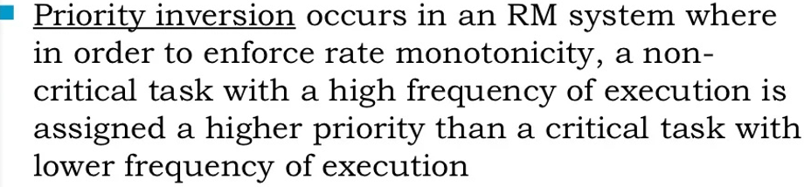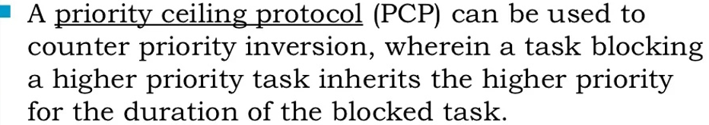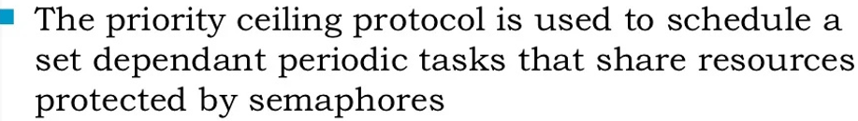

- Explain two concept of Priority Kernel based. [10]
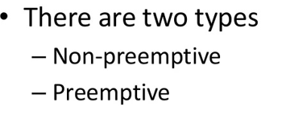
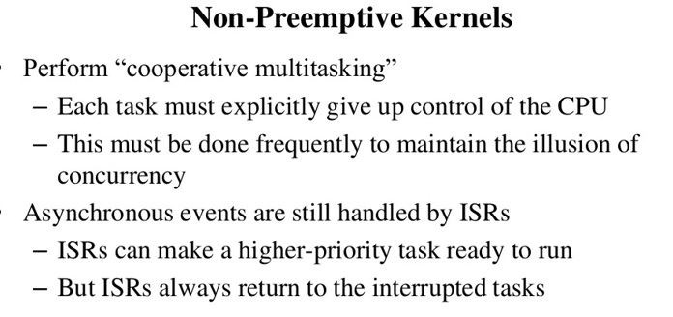
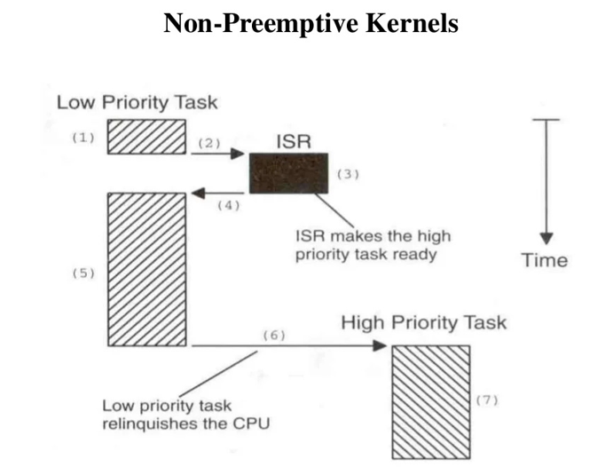
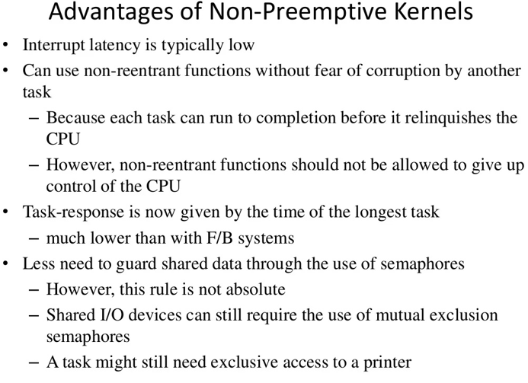
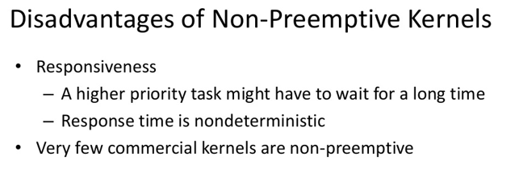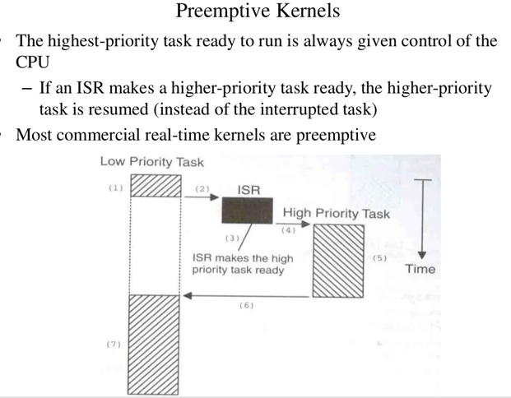
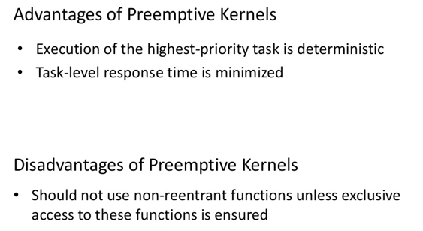
- Explain briefly the concept of systems call usage. [4]

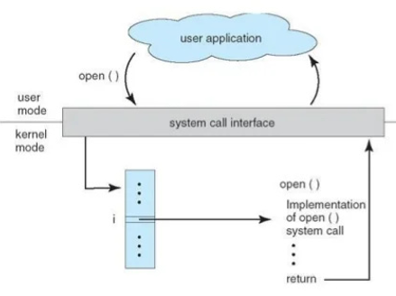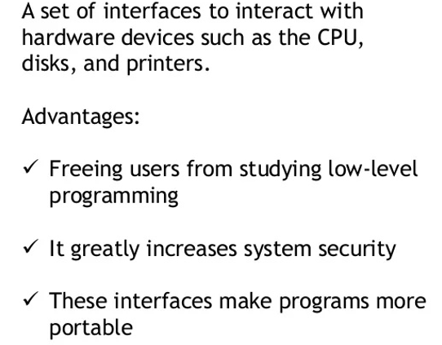

QUESTION FOUR [20]
- Describe various stages that are involved in Task Management. [10]
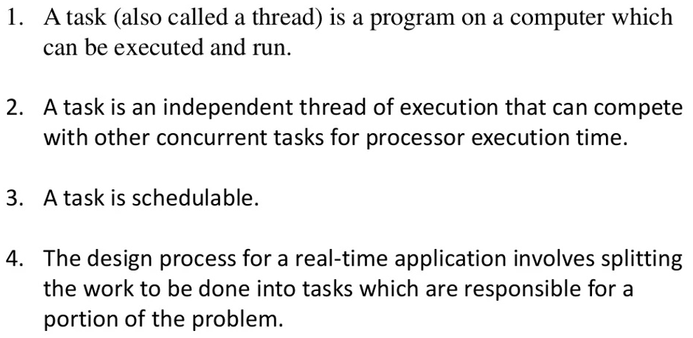
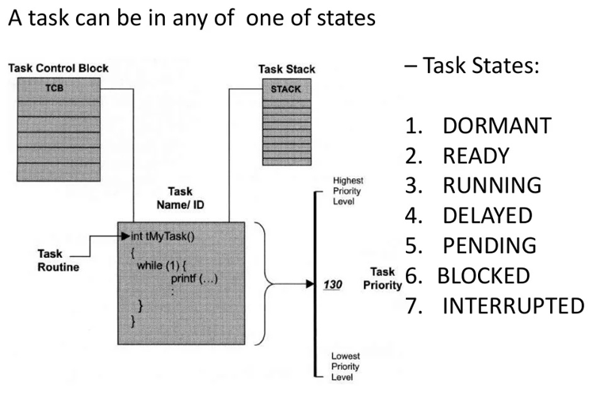
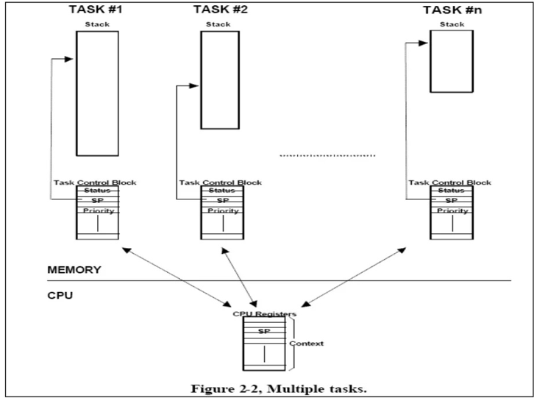
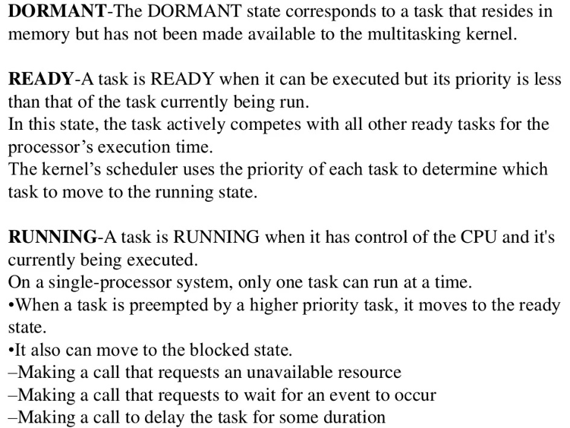
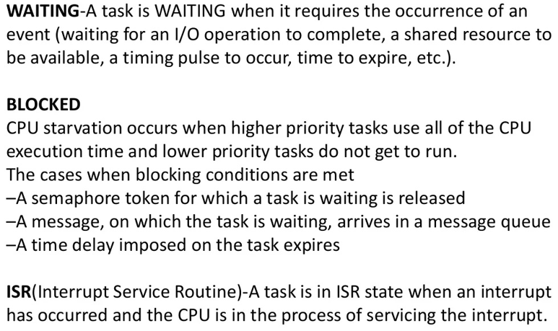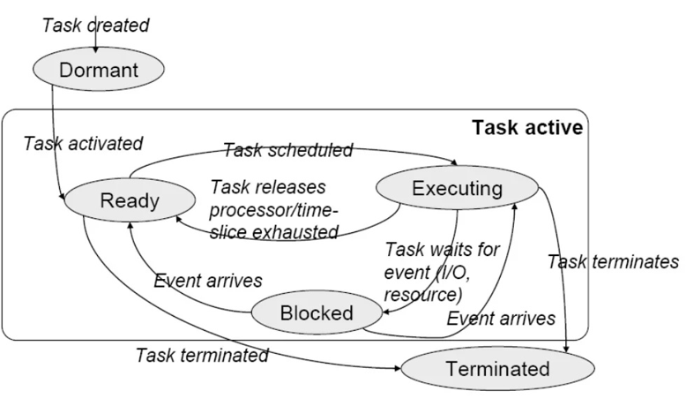
- Explain the basic principle control flow in the operating system based on the various level listed below: [10]
- – interrupt in Operating system
- Exception in Operating system
- – system call in Operating system
interrupt in Operating system
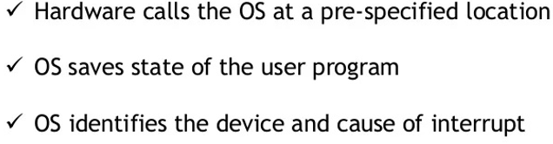
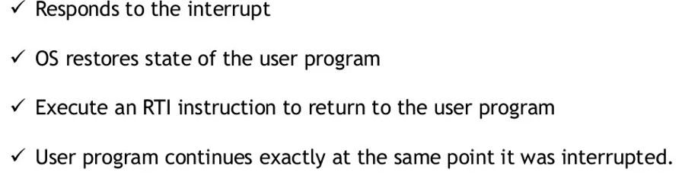

What is control flow – Exception in Operating system
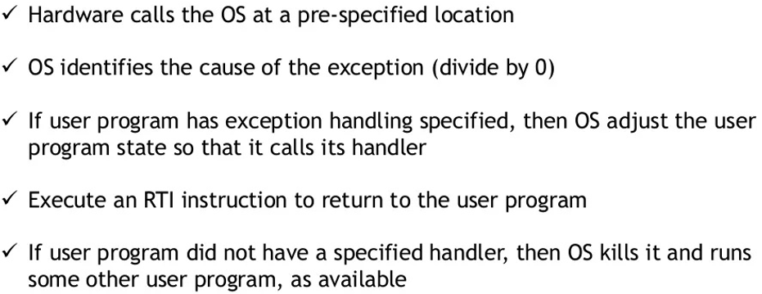
control flow – system call in Operating system
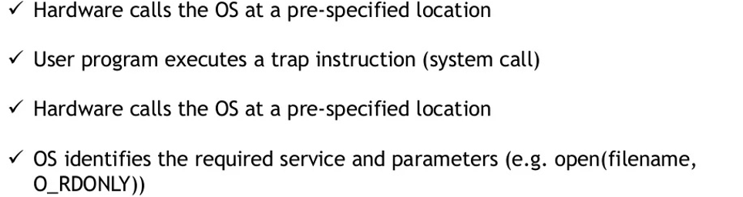
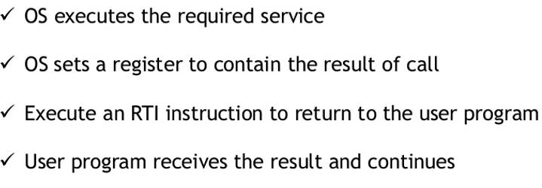

QUESTION FIVE [20]
  - In real time programming, show how Inter process Communication Mechanism takes place. [6]
- Signals-Unix supports another, very simple communication mechanism-the signal.
- A signal is simple because it does not pass data beyond the existence of the signal itself. Signals in UML-A UML signal is actually a generalization of the Unix signal.
- While a Unix signal carries no parameters other than a condition code,a UML signal is an object. Shared Memory Communication-Conceptually, semaphores are the mechanism we use to make shared memory safe.
- POSIX supports semaphores, but it also supports a direct shared memory mechanism. POSIX supports counting semaphores in the _POSIX_SEMAPHORES option. A counting semaphore allows than one process access to a resource at a time.
- Message-Based Communication: -The shell syntax of the pipe is very familiar to Unix users. An example appears below.
% foo file1| baz > file2
- A parent process use the pipe() function to create a pipe to talk to a child. It must do so before the child itself is created or it won’t have any way to pass a pointer to the pipe to the child.
- The pipe () function returns an array of file descriptors, the first for the write end and the second for the read end.
- Explain the three alternative systems in three RTOS for responding a hardware source call with the diagram. [8]
- There are three alternative systems for the RTOSs to respond to the hardware source calls from the interrupts.
Direct call to ISR by an Interrupting Source
- A hardware source calls an ISR directly, and ISR just sends a message to the RTOS. On an interrupt the process running at the CPU is interrupted and the ISR corresponding to that source starts executing.
- RTOS is simply sent a message from the ISR into a mailbox or message queue. It is to inform the RTOS about which ISR has taken control of the CPU.
- The ISR continues execution of the codes needed interrupt service. The routine sends a message for the RTOS.The message is stored at the memory allotted for RTOS messages.
- When TSR finishes, the RTOS returns to the interrupted process or reschedules the processes. RTOS action depends on the messages at the mailbox.
Direct call to RTOS by an Interrupting Source and temporary Suspension of a Scheduled Task
.
- The ISR send a message for initializing the task and returns after restoring the context. The messages are stored at the memory allotted for RTOS messages.
- The RTOS now initiates the task to ready state to later encode needed for the interrupt service. The ISR must be short and it simply places the messages. It is the task that runs the remaining codes whenever it is scheduled. RTOS schedules only- the .processes) and switches the contexts between the tasks only.
ISR executes only during a temporary suspension of a task.
Direct call to RTOS by an Interrupting Source and Scheduling of Tasks as well as IRS by the RTOS
- The RTOS intercepts and executes the task needed on return from the ISR without any message for the task from the ISR. This is shown below
- The routine doesn't T4 any messages but memory sends the IPCs for the needed parameters for a task. Parameters are stored at the memory allotted for the RTOS inputs.
- The RTOS now calls return and restoration of the context and switches the run later the codes needed for the any other task.
- The ISR need not be short and simply generates and saves as the IPCs the input parameters. It is the task that runs the codes whenever RTOS schedules not only the tasks but also the ISRs and switches the contexts as well as the tasks as well as the ISRs.

- Explain the basic function of Vx works and its features [8]
- VxWorks is a Unix-like real-time operating system made and sold by Wind River Systems of Alameda, California" USA. Like most RTOSes, VxWorks includes a multitasking kernel with pre-emptive scheduling and fast interrupt response, extensive inter-process communications and synchronization facilities, and a file system Major distinguishing features of VxWorks include efficient POSlX-compliant memory management, microprocessor facilities, a shell for user interface, symbolic and source level debugging capabilities, and performance monitoring. VxWorks is generally used in embedded systems. Unlike "native" systems such as UNIX and Forth, VxWorks development is done on a "host" machine running Unix or Windows, crosscompiling target software to run on various "target" CPU architectures as well as on the "host" by means of VxSim. VxWorks has been ported to a number of platforms and now runs on practically any modern CPU that is used in the embedded market. This includes the x 86 families, MIPS, PowerPC, SH-4 and the closely related family of ARM, StrongARM and xScale CPUs
- VxWorks System Functions and System Tasks
- The first task that a scheduler executes is UsrRoot from the entrv point of usrRoot0 in file
- install/Dir/target /config/alI / usr/Confi g. c.
- It spawns the VxWorks tools and the following tasks. The root terminates after all the initializations. Any root task can be initialized or terminated. The set of functions, tlog Task, logs the system message without current task context I/O.
- Interrupt handling functions
- An internal hardware device auto generates an interrupt vector address, ISR- ECTADDR as per the device. Exceptions are defined in the us6r software.
- ISR Design
- ISR have the highest priority and can preempt any running task.
- An ISR inhibits the execution of the tasks till return’.
- An IRS does not execute like a task and does not have regular task context. It has special interrupt context'
- While each task has its own stack" unless and otherwise not permitted -by a special architecture of a System or a processor
- An ISR should not wait for taking the semaphore or other IPC.
- ISR should just write the required data at the memory or post an IPC so that it has short codes and most of its functions, execute at tasks.
- ISR should not use flodting-point functions as these takes longer time to execute.
- Signals and interrupt handling functions
- Function 'void sigHandler(int sigNum)' declares a signal servicing routine for a signal identified by sigNum and a signal servicing routine registers a signal as follows:
- Signal (sigNum, sigISR). The parameters that pass are the sigNum and signal servicing routine name, sigISR.A pointwer pSigCtx associates with the signal context. The signal xcontewxt savwes PC, SP, registers, etc. like an ISR context.
- The signal ISR calls the following functions: Call taskRestart0, to restart the task which generated the sigNum. Call exit0 to terminate the task, which generated the sigNum.
- Call longiumpO. This results in starting the. Execution from a memory location.

